

**NAME- ASHISH KUMAR**

**ROLL NO. - 2214102028**

**PROJECT NAME-**  **PUMP IT UP**

**COURSE - BCA**

**SEMESTER - 6TH SEMESTER**

**SUBJECT NAME – BCA - FINAL PROJECT**

**SUBMITTED TO - MANIPAL UNIVERSITY JAIPUR**

1. **Introduction…………………………………………………………………………...…4**

**1.1Objectives……………………………………………………………………..………4**

**2. System Analysis………………………...………………………………………….......….5**

**2.1. Identification of Need………………………..……………………………….….......…5**

**2.2 Preliminary Investigation………………………...…………………………….......…..5**

**2.3 Feasibility Study………………………...………………………………………........…5**

**2.4 Project Planning………………………...………………………………………........5-6**

**3. SOFTWARE REQUIREMENT SPECIFICATIONS (SRS)…………………….......…7**

**3.1 Software Engineering Paradigm Applied………………………...…………............…7**

**3.2 Data Models………………………...………………………………………….............…7**

**4. SYSTEM DESIGN………………………...………………………………...................…8**

**4.1 Modularisation Details………………………...……………………………….….......…8**

**4.2 Data Integrity and Constraints……………...……………………………….............….8**

**4.3 Database Design, Procedural Design/Object Oriented Design……………………......8**

**4.4 User Interface Design………………………...………………………………..........……8**

**5. CODING………………………...……………………………………………................…9**

**5.1 SQL Commands………………………...………………………………......................…9**

**5.2 Standardization of the Coding………………………...………………..……............…9**

**5.3 Code Efficiency………………………...……………………………………..…...........10**

**5.4 Error Handling………………………...……………………………………..…...........10**

**5.5 Parameters Calling/Passing………………………...…………………….……............10**

**5.6 Validation Checks………………………...……………………………….....................10**

**6. TESTING………………………...…………………………………………..…….......…11**

**6.1 Testing Techniques and Strategies Used…………………………….………….......…11**

**6.2 Testing Plan Used………………………...……………………………...……….......…11**

**6.3 Test Reports………………………...…………………………………………...........…11**

**6.4 Debugging and Code Improvement………………………...……………….........……11**

**7. SYSTEM SECURITY MEASURES………………………...…………………..........…12**

**7.1 Database/Data Security Implementation………………………..……………….........12**

**7.2 Creation of User Profiles………………………...……………………………...….......12**

**7.3** **Managing the User Rights………………………...………………………………....…12**

**8. COST ESTIMATION AND ITS MODEL………………………...………….….......…13**

**9.** **FUTURE SCOPE………………………...………………………………………........…14**

**10. Bibliography………………………...…………………………………………….......…15**

**11. Appendices………………………...………………………………….……….......…16-25**

**12. Data Dictionary………………………...………………………………................…….26**

**1. INTRODUCTION**

The "PUMP it UP" project is a dynamic web-based fitness application designed to cater to the needs of gym enthusiasts seeking to optimize their fitness regimens. In an era where health and fitness have become paramount, there is a growing demand for accessible, user-friendly tools that enable individuals to monitor and enhance their physical well-being. This application addresses the rising trend of fitness consciousness by providing a comprehensive platform that integrates essential calculators, user management, and premium content to support users in achieving their fitness goals. Developed using Python with the Flask framework, MySQL for database management, and HTML/CSS/JavaScript for a responsive user interface, "PUMP it UP" leverages modern web technologies to deliver a scalable, secure, and engaging experience. The project emerged from initial research into existing fitness applications, identifying gaps such as complex interfaces, limited free features, and inadequate premium content integration. Surveys among gym-goers highlighted the need for simple, effective tools like BMI and BMR calculators, secure user profiles, and access to professional workout resources, forming the foundation for this innovative solution. By deploying the application on platforms like Heroku, "PUMP it UP" aims to be publicly accessible, ensuring it reaches a broad audience while maintaining robust functionality and user satisfaction.

**1.1 OBJECTIVES**

The primary objectives of the "PUMP it UP" project are multifaceted, focusing on delivering a high-quality fitness tool that meets user needs and supports business growth. The application seeks to provide users with accurate and accessible tools to calculate key fitness metrics, including Body Mass Index (BMI), Basal Metabolic Rate (BMR), protein intake, and daily calorie needs, enabling gym enthusiasts to track and optimize their health effectively. A core goal is to enhance user engagement through an intuitive interface, offering both free and premium features to cater to diverse user segments—free users access basic calculators, while premium users unlock advanced features such as detailed nutrition tips, workout videos, diet charts, and specialized calculators for creatine and nutrition requirements. The project aims to ensure security and scalability by implementing hashed passwords, HTTPS via Heroku, and a MySQL database, while maintaining performance and usability across devices. Additionally, "PUMP it UP" targets profitability through premium subscriptions, with a future scope for mobile app integration, AI-driven recommendations, and community features, positioning it as a leading fitness solution in the digital health landscape.

**2. System Analysis**

**2.1. Identification of Need:** The increasing popularity of fitness and health-conscious lifestyles has created a demand for personalized tools to monitor fitness metrics and access professional guidance. Gym enthusiasts require an accessible, user-friendly platform to calculate BMI, BMR, and nutrition needs, track progress, and access premium content like workout videos and diet charts. "PUMP it UP" addresses this need by offering a comprehensive, secure, and scalable solution.

**2.2 Preliminary Investigation**

Initial research involved analysing existing fitness apps (e.g., MyFitnessPal, Fitbit) and identifying gaps such as complex interfaces, limited free features, and poor integration of premium content. Surveys among gym-goers revealed a need for simple calculators, secure user profiles, and premium workout resources, leading to the conceptualization of "PUMP it UP."

**2.3 Feasibility Study**

1. **Technical Feasibility:** The project leverages Python (Flask), MySQL, HTML/CSS/JavaScript, and YouTube embeds, all of which are well-supported and scalable technologies.
2. **Economic Feasibility**: Development costs are minimal (free tools like VS Code, Heroku), with potential revenue from premium subscriptions.
3. **Operational Feasibility:** The application is user-friendly, requiring minimal training, and operates on standard web browsers.
4. **Legal Feasibility:** Ensures compliance with data privacy laws (e.g., GDPR) by securing user data with hashed passwords and optional HTTPS.

**2.4 Project Planning**

**a. Project Scheduling (PERT Chart & Gantt Chart)**

**PERT Chart:** Activities include requirement gathering (2 weeks), design (3 weeks), coding (4 weeks), testing (2 weeks), and deployment (1 week). Critical path: Requirement → Design → Coding → Testing → Deployment (total 12 weeks).

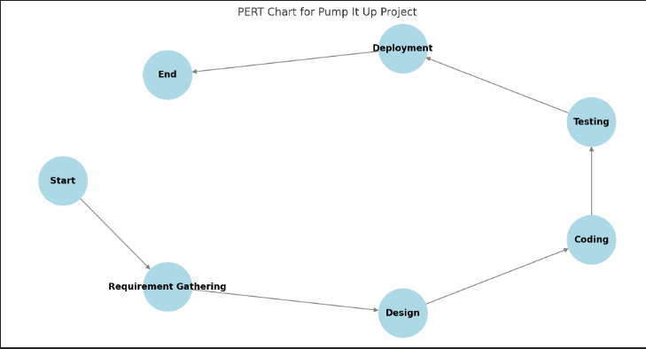

Image: Pert Chart

I**b. Gantt Chart:** Visual timeline in Microsoft Project or Excel, showing overlapping tasks (e.g., design and coding partially concurrent), with milestones like "Prototype Ready" (Week 5) and "Deployed to Heroku" (Week 12).

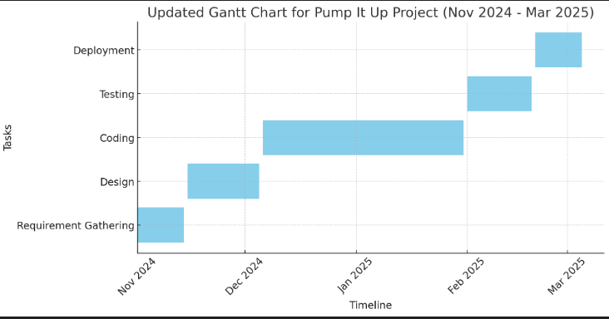

Image: Gantt Chart

**3. SOFTWARE REQUIREMENT SPECIFICATIONS (SRS)**

**Functional Requirements:** User registration/login, BMI/BMR/protein calculators, premium features (nutrition tips, workout videos, diet charts), progress tracking, contact form.

**Non-Functional Requirements:** Scalability (Heroku), security (hashed passwords, HTTPS), usability (responsive design), performance (load time < 2s).

**Hardware Requirements:**  Standard PC/laptop, internet connectivity.

**Software Requirements:** Python 3.x, Flask, MySQL, Gunicorn, HTML/CSS/JavaScript.

**3.1 Software Engineering Paradigm Applied**

The project follows the Agile development model, with iterative sprints (2-week cycles) for requirement analysis, design, coding, and testing, allowing flexibility for user feedback and feature enhancements.

**3.2 Data Models**

**Data Flow Diagram (DFD):** Level 0 DFD shows data flows between user input (e.g., weight, height), application processes (calculators, database), and outputs (results, premium content). Level 1 DFD details processes like user authentication, calculation logic, and database updates.

**Entity Relationship Model (ERD):** Entities include `users` (username, password, email, is_premium, weight, height, age, gender) and `progress` (username, date, weight), linked by a foreign key relationship.

**Use-case Diagram:** Actors (User, Premium User) interact with use cases (Login, Calculate BMI, Access Premium Workouts, Track Progress).

**Class Diagram:** Classes include `User` (attributes: username, email, etc.), `Calculator` (methods: calculate_bmi, calculate_bmr), and `Database` (methods: connect, insert, update).

**4. SYSTEM DESIGN**

**4.1 Modularisation Details**

The system is modularized into:

**User Management:** Handles login/register, premium status, and profile updates.

**Calculators:** Implements BMI, BMR, protein, calories, creatine, and nutrition calculations.

**Database:** Manages MySQL tables (`users`, `progress`) for data storage.

**UI:** Flask templates (HTML/CSS/JavaScript) for responsive design.

**4.2 Data Integrity and Constraints**

a. **MySQL constraints:** **`PRIMARY KEY`** (id, username), **`UNIQUE`** (username, email), **`FOREIGN KEY`** (username in progress table), **`NOT NULL`** for critical fields.

b. Data validation ensures positive numeric inputs and valid email formats.

**4.3 Database Design, Procedural Design/Object Oriented Design**

**users Table:** *`id (INT, PRIMARY KEY)`, `username (VARCHAR, UNIQUE)`, `password (VARCHAR, NOT NULL)`, `is_premium (BOOLEAN)`, `email (VARCHAR, UNIQUE)`, `weight (FLOAT)`, `height (FLOAT)`, `age (INT)`, `gender (VARCHAR)`.*

**progress Table**: *`id (INT, PRIMARY KEY)`, `username (VARCHAR, FOREIGN KEY)`, `date (DATE)`, `weight (FLOAT)`.*

Uses object-oriented design with Python classes (e.g., *`User`, `Calculator’*) and procedural functions (e.g., database operations, route handlers).

**4.4 User Interface Design**

v Responsive layout using CSS *`@media`* queries for desktops, tablets, and mobiles.

v Black/gray/silver color scheme, red headings, white **"PUMP it UP"** text, full-screen gym background, smaller inputs (200px).

**5. CODING**

**5.1 SQL Commands**

**5.1.1 Database Creation:**

*CREATE DATABASE pump_it_up;*

*USE pump_it_up;*

*CREATE TABLE users (*

*id INT AUTO_INCREMENT PRIMARY KEY,*

*username VARCHAR(50) UNIQUE NOT NULL,*

*password VARCHAR(255) NOT NULL,*

*is_premium BOOLEAN DEFAULT FALSE,*

*email VARCHAR(100) UNIQUE NOT NULL,*

*weight FLOAT,*

*height FLOAT,*

*age INT,*

*gender VARCHAR(10)*

*);*

*CREATE TABLE progress (*

*id INT AUTO_INCREMENT PRIMARY KEY,*

*username VARCHAR(50),*

*date DATE,*

*weight FLOAT,*

*FOREIGN KEY (username) REFERENCES users(username)*

*);*

**5.1.2 Data Insertion:**

*INSERT INTO users (username, password, email, is_premium) VALUES ('testuser', 'hashed_password', 'test@example.com', FALSE);*

*INSERT INTO progress (username, date, weight) VALUES ('testuser', '2025-03-01', 70.0);*

**5.1.3 Access Rights:**

*GRANT SELECT, INSERT, UPDATE ON* ***pump_it_up.*** *TO 'user'@'localhost' IDENTIFIED BY 'password';*

**5.2 Standardization of the Coding**

Followed PEP 8 for Python (consistent indentation, naming conventions).

Used Flask’s routing structure, MySQL queries, and HTML5/CSS3 standards.

**5.3 Code Efficiency**

Minimized database queries with efficient joins and indexes.

Used caching for static content (CSS, JavaScript, images) via Flask’s static file serving.

**5.4 Error Handling**

Implemented try/except blocks for database operations, calculations, and form submissions.

Flashed user-friendly error messages (e.g., “Invalid positive numbers!”).

**5.5 Parameters Calling/Passing**

- Used Flask’s `request.form` for POST data, session variables for user state, and MySQL parameters for secure queries.

**5.6 Validation Checks**

Client-side (JavaScript): Real-time validation for form inputs (positive numbers, email format).

Server-side (Python): Validated numeric inputs, password hashing, and database constraints.

**6. TESTING**

**6.1 Testing Techniques and Strategies Used**

**Unit Testing:** Tested individual functions (e.g., ***`calculate_bmi`, `calculate_bmr`***) using Python’s unittest.

**Integration Testing**: Ensured modules (UI, database, calculators) worked together via Flask routes.

**System Testing:** Verified end-to-end functionality (login, calculations, premium access) on Heroku.

**6.2 Testing Plan Used**

Created test cases for user registration, login, calculator outputs, premium features, and database operations.

Used a test matrix: Inputs (valid/invalid), Outputs (expected/actual), and Pass/Fail status.

**6.3 Test Reports**

**Unit Test Cases:** *`calculate_bmi(70, 1.75)` → 22.86 (Pass), `calculate_bmi(-70, 1.75)` → “Invalid” (Pass).*

**System Test Cases:** Login with valid credentials → Success (Pass), Premium access without login → Redirect with error (Pass).

**6.4 Debugging and Code Improvement**

Used Flask’s debug mode and Heroku logs for debugging.

Optimized database queries with indexes and reduced redundant calculations.

**7. SYSTEM SECURITY MEASURES**

**7.1 Database/Data Security Implementation**

Hashed passwords with **`bcrypt`.**

SSL/TLS via Heroku for HTTPS.

Environment variables for sensitive data (MySQL credentials, Gmail).

**7.2 Creation of User Profiles**

Users register with username, password, and email, stored in MySQL with `is_premium` status.

Premium users access additional features via session checks.

**7.3** **Managing the User Rights**

Free users access basic calculators and free content.

Premium users (via `is_premium = TRUE`) access workouts, advanced calculators, and diet charts.

**8. COST ESTIMATION AND ITS MODEL**

**COCOMO Model:** Used Basic COCOMO for effort estimation (e.g., 12 person-months for a semi-detached project).

**Cost:** Free tools (VS Code, Heroku free tier), minimal hardware (standard PC), INR 0 for development, potential revenue from premium subscriptions.

**9.** **FUTURE SCOPE**

### Future Scope of "PUMP it UP" Fitness Web Application

* Mobile App Integration (React Native or Flutter)  
  1. Develop cross-platform mobile apps (iOS & Android).
  2. Provide on-the-go access to calculators, workout plans, and progress tracking.
  3. Enhance usability and engagement with a native app experience.
* AI-Driven Workout Recommendations & Progress Predictions  
  1. Implement machine learning algorithms to analyze user data (weight, activity level, goals).
  2. Provide personalized workout routines and predict progress trends.
  3. Optimize fitness outcomes with a data-driven approach.
* Community Forums & Fitness Challenges  
  1. Introduce discussion boards for user interaction and support.
  2. Enable users to share tips, experiences, and fitness journeys.
  3. Organize time-bound challenges (e.g., 30-day plank challenge) to boost motivation and retention.

**10. Bibliography**

Flask Documentation: *https://flask.palletsprojects.com/*

MySQL Documentation: *https://dev.mysql.com/doc/*

W3Schools HTML/CSS/JavaScript: *https://www.w3schools.com/*

Heroku Deployment Guide: [*https://devcenter.heroku.com/*](https://devcenter.heroku.com/)

VIPLOVE JAIN (2025). Personal guidance and technical support for "PUMP it UP" project development [TRANSCEND INFOSYSTEM PVT. LTD.].

**11. Appendices**

Some images of my project (website) are shown below.

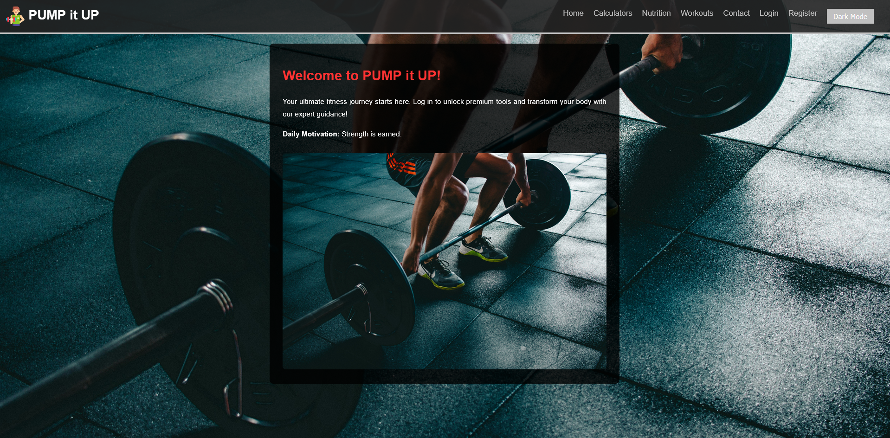Image- Homepage of Website Pump It Up

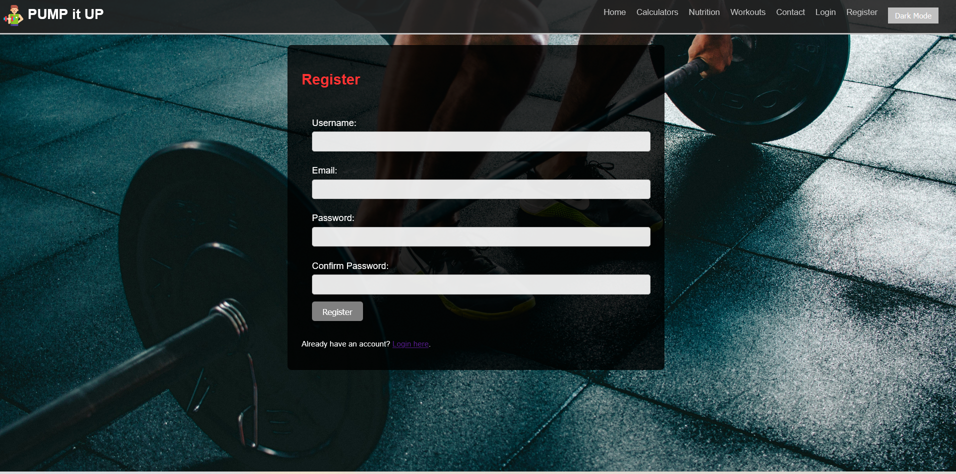

Image- Register Page of Pump It Up

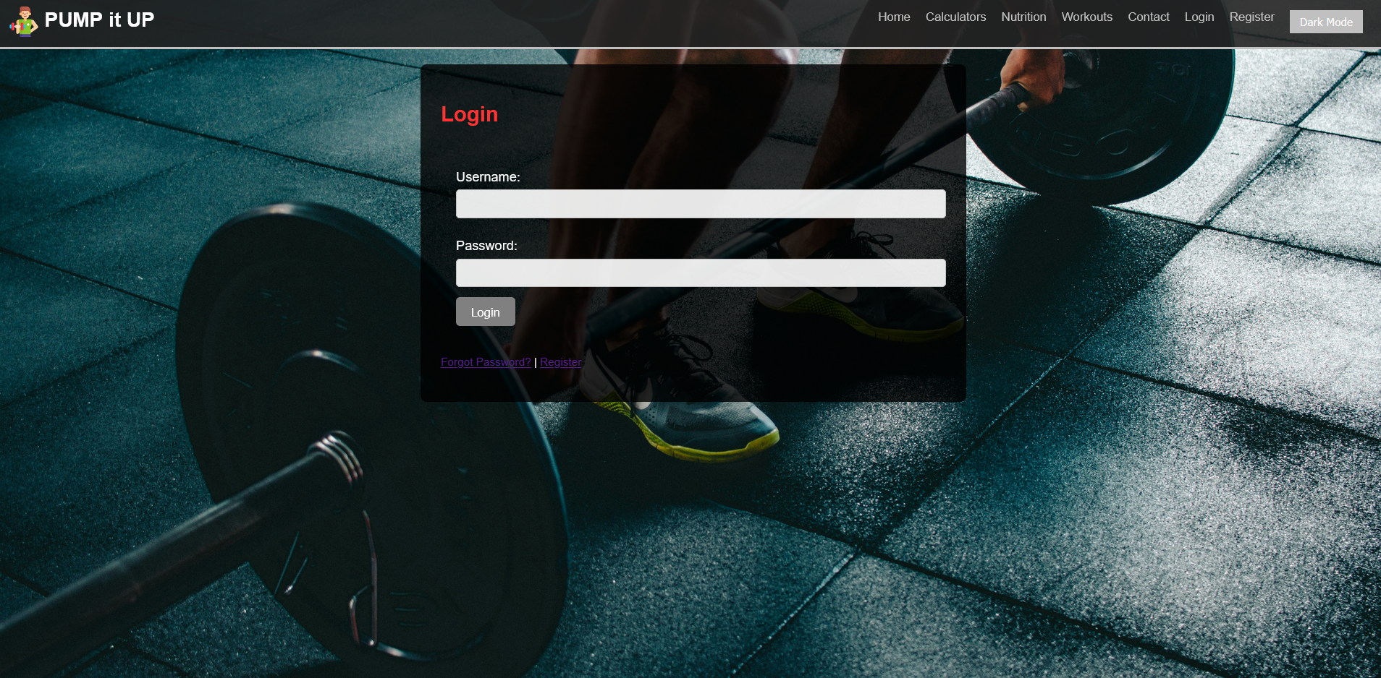

Image-Login Page of Pump It Up

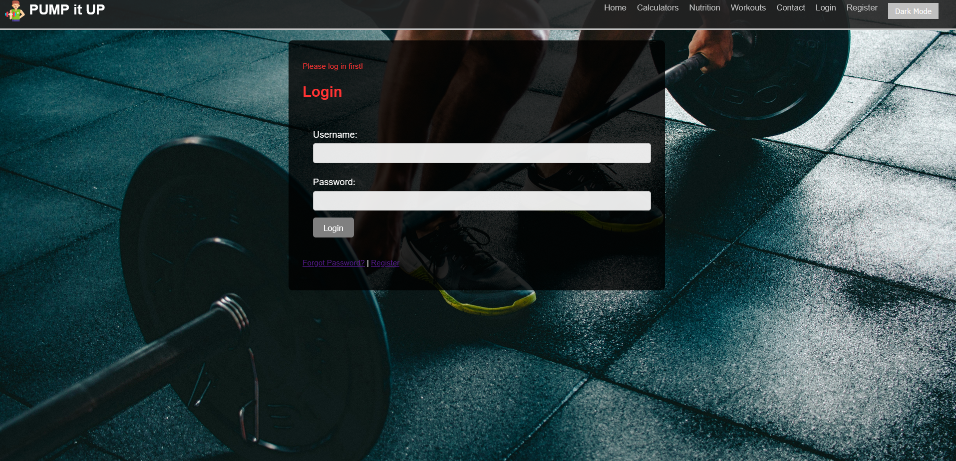

Image: Pop up message before without login

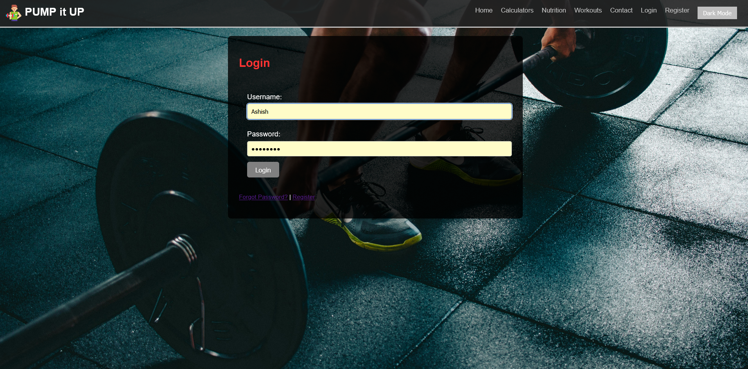

Image: Page before Login

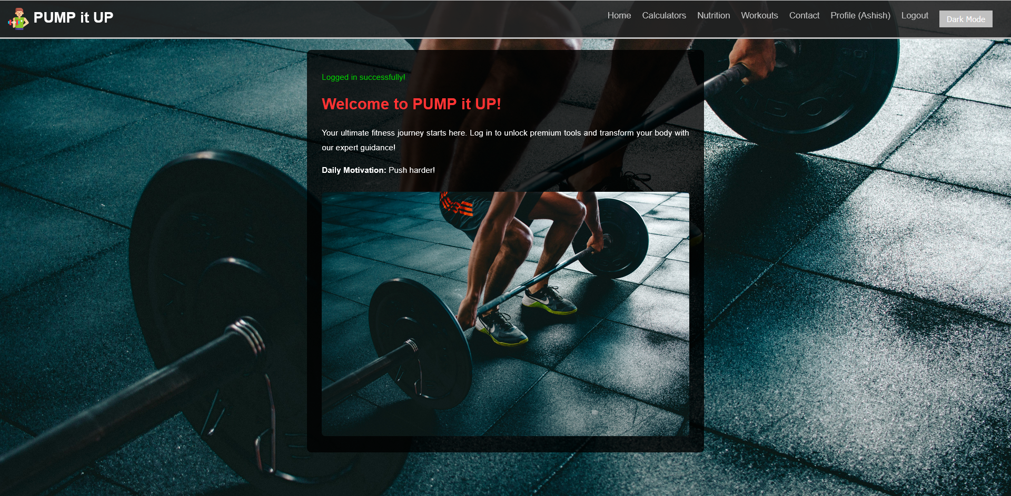

Image: Page After Login

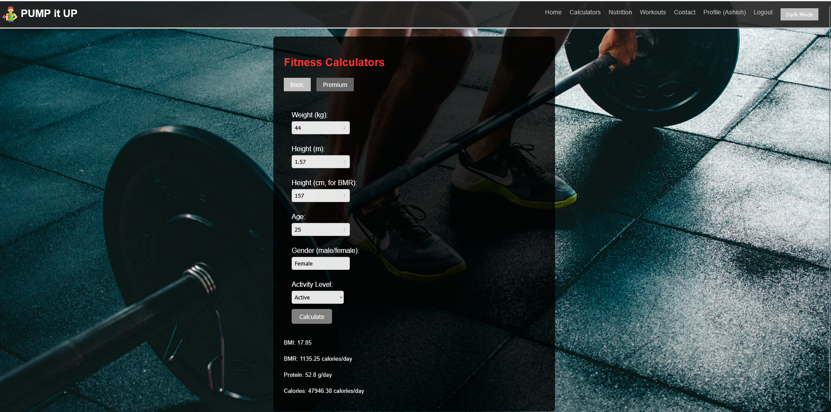

Image: Calculators

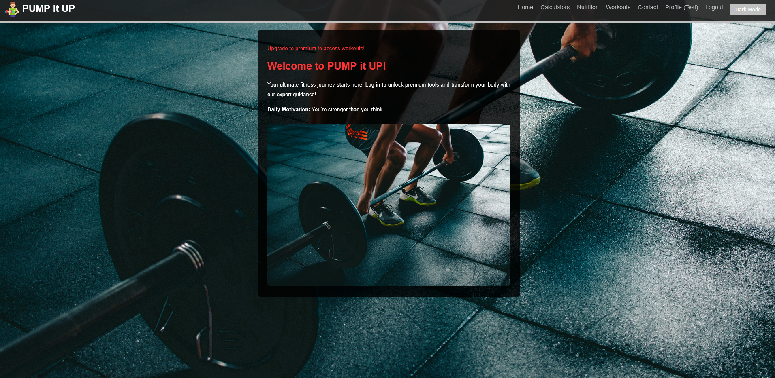

Image: Pop-Up show for non Premium users

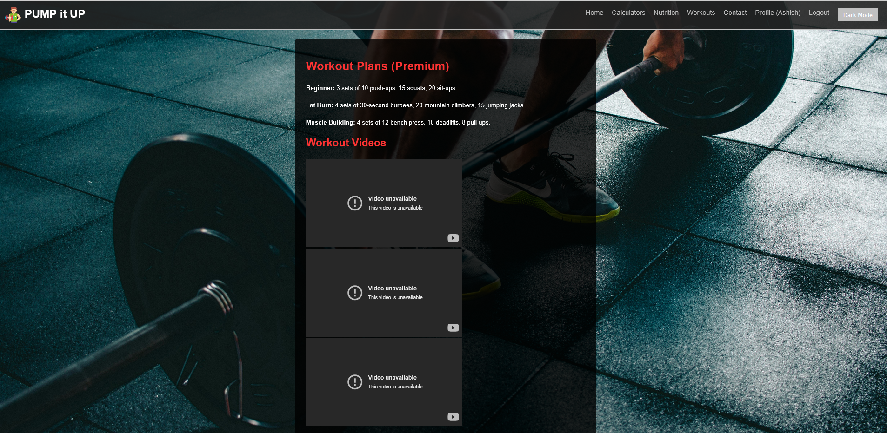Image: Gym Workout for Premium User

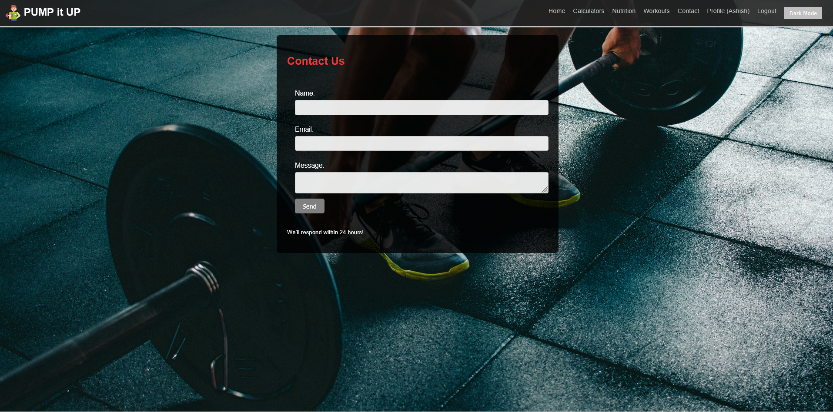

Image: Contact page

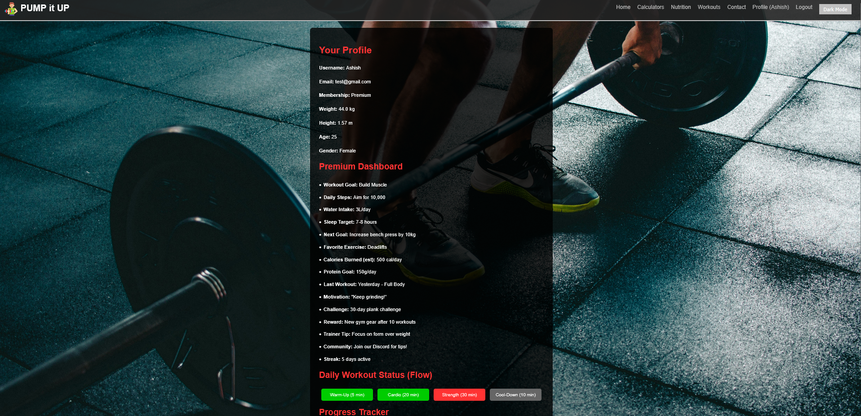

Image: Profile

**Full SQL dump of `pump_it_up` database.**

*-- MySQL dump 10.13 Distrib 8.0.41, for Win64 (x86_64)*

*--*

*-- Host: localhost Database: pump_it_up*

*-- ------------------------------------------------------*

*-- Server version 8.0.41*

*/*!40101 SET @OLD_CHARACTER_SET_CLIENT=@@CHARACTER_SET_CLIENT */;*

*/*!40101 SET @OLD_CHARACTER_SET_RESULTS=@@CHARACTER_SET_RESULTS */;*

*/*!40101 SET @OLD_COLLATION_CONNECTION=@@COLLATION_CONNECTION */;*

*/*!50503 SET NAMES utf8 */;*

*/*!40103 SET @OLD_TIME_ZONE=@@TIME_ZONE */;*

*/*!40103 SET TIME_ZONE='+00:00' */;*

*/*!40014 SET @OLD_UNIQUE_CHECKS=@@UNIQUE_CHECKS, UNIQUE_CHECKS=0 */;*

*/*!40014 SET @OLD_FOREIGN_KEY_CHECKS=@@FOREIGN_KEY_CHECKS, FOREIGN_KEY_CHECKS=0 */;*

*/*!40101 SET @OLD_SQL_MODE=@@SQL_MODE, SQL_MODE='NO_AUTO_VALUE_ON_ZERO' */;*

*/*!40111 SET @OLD_SQL_NOTES=@@SQL_NOTES, SQL_NOTES=0 */;*

*--*

*-- Table structure for table `progress`*

*--*

*DROP TABLE IF EXISTS `progress`;*

*/*!40101 SET @saved_cs_client = @@character_set_client */;*

*/*!50503 SET character_set_client = utf8mb4 */;*

*CREATE TABLE `progress` (*

*`id` int NOT NULL AUTO_INCREMENT,*

*`username` varchar(50) DEFAULT NULL,*

*`date` date DEFAULT NULL,*

*`weight` float DEFAULT NULL,*

*PRIMARY KEY (`id`),*

*KEY `username` (`username`),*

*CONSTRAINT `progress_ibfk_1` FOREIGN KEY (`username`) REFERENCES `users` (`username`)*

*) ENGINE=InnoDB AUTO_INCREMENT=9 DEFAULT CHARSET=utf8mb4 COLLATE=utf8mb4_0900_ai_ci;*

*/*!40101 SET character_set_client = @saved_cs_client */;*

*--*

*-- Dumping data for table `progress`*

*--*

*LOCK TABLES `progress` WRITE;*

*/*!40000 ALTER TABLE `progress` DISABLE KEYS */;*

*INSERT INTO `progress` VALUES (1,'Ashish','2025-03-01',62),(2,'Ashish','2025-03-01',64),(3,'Ashish','2025-03-01',82),(4,'Ashish','2025-03-01',44),(5,'Ashish','2025-03-01',42),(6,'Saurabh ','2025-03-02',69),(7,'Saurabh ','2025-03-02',72),(8,'Ashish','2025-03-02',44);*

*/*!40000 ALTER TABLE `progress` ENABLE KEYS */;*

*UNLOCK TABLES;*

*--*

*-- Table structure for table `users`*

*--*

*DROP TABLE IF EXISTS `users`;*

*/*!40101 SET @saved_cs_client = @@character_set_client */;*

*/*!50503 SET character_set_client = utf8mb4 */;*

*CREATE TABLE `users` (*

*`id` int NOT NULL AUTO_INCREMENT,*

*`username` varchar(50) DEFAULT NULL,*

*`password` varchar(255) DEFAULT NULL,*

*`is_premium` tinyint(1) DEFAULT '0',*

*`email` varchar(100) DEFAULT NULL,*

*`weight` float DEFAULT NULL,*

*`height` float DEFAULT NULL,*

*`age` int DEFAULT NULL,*

*`gender` varchar(10) DEFAULT NULL,*

*PRIMARY KEY (`id`),*

*UNIQUE KEY `username` (`username`)*

*) ENGINE=InnoDB AUTO_INCREMENT=5 DEFAULT CHARSET=utf8mb4 COLLATE=utf8mb4_0900_ai_ci;*

*/*!40101 SET character_set_client = @saved_cs_client */;*

*--*

*-- Dumping data for table `users`*

*--*

*LOCK TABLES `users` WRITE;*

*/*!40000 ALTER TABLE `users` DISABLE KEYS */;*

*INSERT INTO `users` VALUES (1,'Ashish','$2b$12$7QBHOLKvIHFAMLbatvEgN.5Rh9aeCNWqSkWqgtjFadxpHqS/X/bCK',1,'test@gmail.com',44,1.57,25,'Female'),(2,'Test','$2b$12$UBcQcxFzBs3bNlBrFIclAeExGDba5MjybyNfnDI/wt/VtqRTISHUC',0,'test@gmail.com',NULL,NULL,NULL,NULL),(3,'unknown','$2b$12$N7HqLTcqaTzgmzIcLweb/.42mpxkR3hi7HNm3YdN4Q2eRW9/Yek8S',0,'rraj7895@gmail.com',NULL,NULL,NULL,NULL),(4,'Saurabh ','$2b$12$b0f/fh3VgtPuY8Xh.DHS7eY1cK7Qunz7bqHiCffig8zj/vomEWxV.',1,'Saurabh@gmail.com',69,1.83,21,'Male');*

*/*!40000 ALTER TABLE `users` ENABLE KEYS */;*

*UNLOCK TABLES;*

*/*!40103 SET TIME_ZONE=@OLD_TIME_ZONE */;*

*/*!40101 SET SQL_MODE=@OLD_SQL_MODE */;*

*/*!40014 SET FOREIGN_KEY_CHECKS=@OLD_FOREIGN_KEY_CHECKS */;*

*/*!40014 SET UNIQUE_CHECKS=@OLD_UNIQUE_CHECKS */;*

*/*!40101 SET CHARACTER_SET_CLIENT=@OLD_CHARACTER_SET_CLIENT */;*

*/*!40101 SET CHARACTER_SET_RESULTS=@OLD_CHARACTER_SET_RESULTS */;*

*/*!40101 SET COLLATION_CONNECTION=@OLD_COLLATION_CONNECTION */;*

*/*!40111 SET SQL_NOTES=@OLD_SQL_NOTES */;*

*-- Dump completed on 2025-03-02 16:23:32*

**12. Data Dictionary**

**Users**:

**`id`:** Integer, Primary Key, Auto-incremented.

**`username`:** VARCHAR(50), Unique, Not Null, User identifier.

**`password`:** VARCHAR(255), Not Null, Hashed user password.

**`is_premium`:** BOOLEAN, Default False, Premium status flag.

**`email`:** VARCHAR(100), Unique, Not Null, User contact.

**`weight`:** FLOAT, Optional, User’s current weight in kg.

**`height`:** FLOAT, Optional, User’s height in meters.

**`age`:** INT, Optional, User’s age in years.

**`gender`:** VARCHAR(10), Optional, User’s gender.

**progress:**

**`id`:** Integer, Primary Key, Auto-incremented.

**`username`:** VARCHAR(50), Foreign Key, References users(username).

**`date`:** DATE, Not Null, Date of weight entry.

**`weight`:** FLOAT, Not Null, User’s weight on that date.